CR IT Team

crit@ayahealthcare.com

PDF TimeSheet Reader tool

User manual

|  |  |  |
| --- | --- | --- |
| **Date** | **Autor** | **Reason** |
| 08/24/2022 | Luis Gonzalez | Initial release manual |
| 12/21/2022 | Luis Gonzalez | Update to V2, new reports added |
| 05/29/2023 | María José Campos | Update to V3, API Format enhancements |
| 06/12/2023 | María José Campos | New report added UKG Common Format, Update to V4 |
| 06/28/2023 | María José Campos | New Report Added UKG Simplified, Update to V5 |
| 7/19/2023 | María José Campos | New Report Added UKG Kronos, Update to V6 |
| 8/4/2023 | María José Campos | New Report Added Paylocity, Update to V7 |
|  |  |  |
|  |  |  |
|  |  |  |

Contents

Introduction 3

Process to run the Script 4

Startup application 4

Types of Reports 5

Default 5

API Format 8

UKG Common 11

UKG Simplified 14

UKG Kronos 17

Paylocity 20

Error reporting 23

Other errors 23

# Introduction

Some teams in Aya process PDF file reports, these reports must be converted to Excel and then be audited. This script automates the PDF conversion to Excel, the files must be audited manually by the users once they are converted. This script only runs in a specific kind of PDF file, not in every PDF.

# Process to run the Script

## Startup application

1. Graphical user interface, application

   Description automatically generatedOpen the application shortcut: pdfreader.exe

**Note:** If you cannot locate the shortcut, the execution (.exe) file is in the following path*C:\dist\pdfreader* *pdfreader.exe*

1. Graphical user interface, application

   Description automatically generatedOnce the application opens it will show a window like this:
2. Choose the report type that you want to process on the “Select Report Type” options. Depending on the format the steps may change, continue with the corresponding steps in each format.

## Types of Reports

### Default

This option is usually used to process the mayor part of the reports, such as Piedmont, Allina, PeaceHealth, Northside, Kronos, Baptist, etc. Those reports have the following format:

1. Select the PDF file that you want to process from your documents library by using the “Open a File” button.

**Note**: If you choose “Default” you only can process one file at a time.

1. Select if the hours' total amount should be rounded.

If you choose “No” the hours' total amount will be the same as the hours in the PDF file. In case you choose “Yes” the minutes on the shifts will be rounded (minutes/60).

1. Start the execution by using the button “Process File”.

Await until the execution ends. If the file PDF is too large the execution could take around 5 minutes running or more.

1. Once the execution ends you will receive the Success message.

**Note:** Scrapper window says is “Not responding”; this is normal. The name of the Excel file has the date and time on it.

1. Open the output files. You can use the shortcut.

**Note**: If you cannot locate the shortcut, the output files are in the following path:

C:\dist\output

#### Output file

Once the script finishes it will generate an Excel file with the following columns.

* Column A: EMPLID
* Column B: NAME
* Column C: DATE
* Column D: AGENCY
* Column E: GLCODE
* Column F: PAYCODE
* Column G: STARTDTM
* Column H: ENDDTM
* Column I: HOURLY RT
* Column J: HOURS
* Column K: WAGES
* Column L: MULTIPLIER
* Column M: ADDER
* Column N: INVOICE ID
* Column O: ApproveByFacility
* Column P: ApproveByAgency
* Column Q: Pool
* Column R: Comments
* A screenshot of a phone

  Description automatically generated with low confidenceColumn S: EntireGLCode

### API Format

This option is used to process the “API clocking” reports. Those reports have the following format:

1. Select the PDF file that you want to process from your documents library by using the “Open a File” button.

**Note**: If you choose “API Format” you can choose more than one file, all the processed files will be on the same output Excel file.

1. A screenshot of a computer

   Description automatically generated with medium confidenceSelect if the SCHED shift is to be excluded from the Output sheet.

If you choose "No" the SCHED shifts will appear on the Output sheet, in case you choose "Yes" the shifts will be excluded from the Output sheet.

1. Start the execution by using the button “Process File”.

Await until the execution ends. If the file PDF is too large the execution could take around 5 minutes running or more.

1. Once the execution ends you will receive the Success message.

**Note:** Scrapper window says is “Not responding”; this is normal. The name of the Excel file has the date and time on it.

 

**Note:** OutputData has only the billing pay codes while RawData has all data from the PDF.

1. Open the output files. You can use the shortcut.

**Note**: If you cannot locate the shortcut, the output files are in the following path:

C:\dist\output

#### Output file

Once the script finishes it will generate an Excel file with the following columns.

* Column A: EMPLID
* Column B: NAME
* Column C: DATE
* Column D: AGENCY
* Column E: GLCODE
* Column F: PAYCODE
* Column G: SPECIAL CODE
* Column H: STARTDTM
* Column I: ENDDTM
* Column J: HOURLY RT
* Column K: HOURS
* Column L: WAGES
* Column M: MULTIPLIER
* Column N: ADDER
* Column O: INVOICE ID
* Column P: ApproveByFacility
* Column Q: ApproveByAgency
* Column R: Pool
* Column S: CODE
* Column T: DEPARTMENT
* Column U: Comments

### UKG Common

This option is used to process the “UKG” reports, such as Martin. Those reports have the following format:

1. Select the PDF file that you want to process from your documents library by using the “Open a File” button.

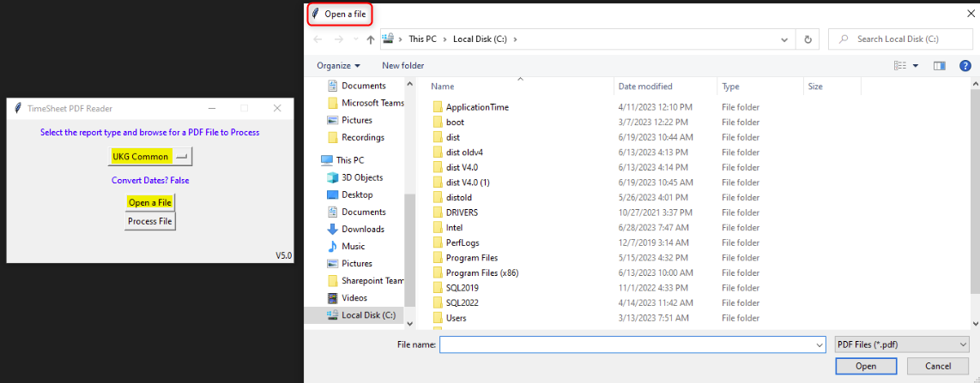 **Note**: If you choose “UKG Common Format” you only can process one file at a time.

1. Start the execution by using the button “Process File”.

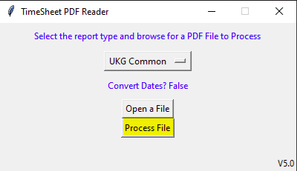Await until the execution ends. If the file PDF is too large the execution could take around 5 minutes running or more.

1. Once the execution ends you will receive the Success message.

**Note:** Scrapper window says is “Not responding”; this is normal. The name of the Excel file has the date and time on it.



1. Open the output files. You can use the shortcut.

**Note**: If you cannot locate the shortcut, the output files are in the following path:

C:\dist\output

#### Output file

Once the script finishes it will generate an Excel file with the following columns.

* Column A: EMPLID
* Column B: NAME
* Column C: DATE
* Column D: AGENCY
* Column E: GLCODE
* Column F: PAYCODE
* Column G: STARTDTM
* Column H: ENDDTM
* Column I: HOURLY RT
* Column J: HOURS
* Column K: WAGES
* Column L: MULTIPLIER
* Column M: ADDER
* Column N: INVOICE ID
* Column O: ApproveByFacility
* Column P: ApproveByAgency
* Column Q: Pool
* Column R: Comments
* Column S: PrimaryJob

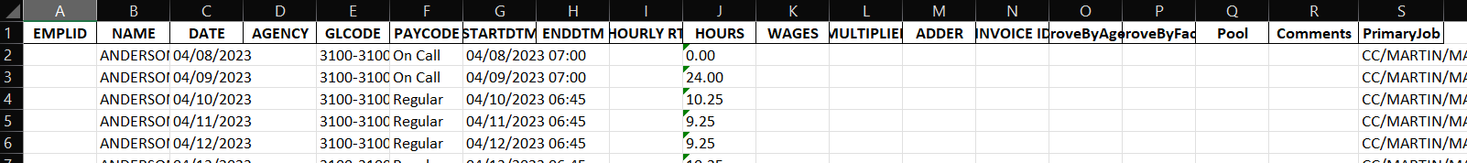

### UKG Simplified

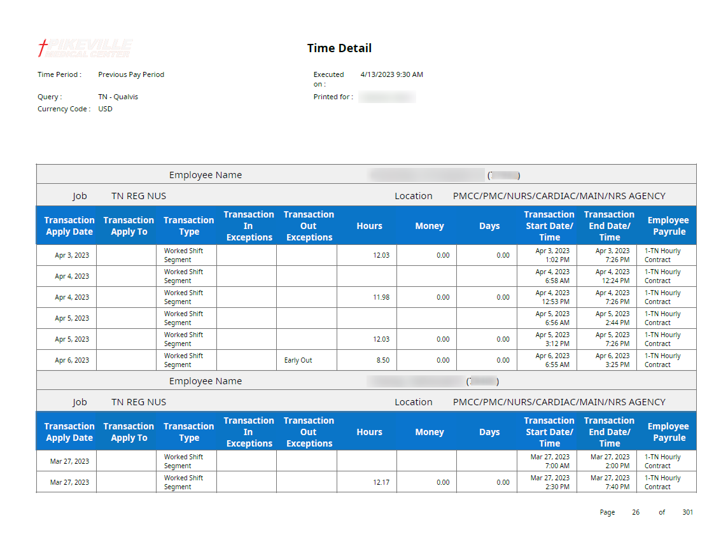This option is used to process simplified "UKG" reports, such as PikeVille. These reports have the following format:

1. Select the PDF file that you want to process from your documents library by using the “Open a File” button.

**Note**: If you choose “UKG Simplified” you only can process one file at a time.

1. Start the execution by using the button “Process File”.

Await until the execution ends. If the file PDF is too large the execution could take around 5 minutes running or more.

1. Once the execution ends you will receive the Success message.

**Note:** Scrapper window says is “Not responding”; this is normal. The name of the Excel file has the date and time on it.



1. Open the output files. You can use the shortcut.

**Note**: If you cannot locate the shortcut, the output files are in the following path:

C:\dist\output

#### Output file

Once the script finishes it will generate an Excel file with the following columns.

* Column A: EMPLID
* Column B: NAME
* Column C: DATE
* Column D: AGENCY
* Column E: GLCODE
* Column F: PAYCODE
* Column G: STARTDTM
* Column H: ENDDTM
* Column I: HOURLY RT
* Column J: HOURS
* Column K: WAGES
* Column L: MULTIPLIER
* Column M: ADDER
* Column N: INVOICE ID
* Column O: ApproveByFacility
* Column P: ApproveByAgency
* Column Q: Pool
* Column R: Comments

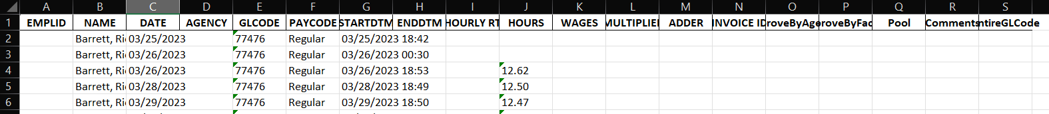

### UKG Kronos

This option is used to process kronos "UKG" reports, such as ADP. These reports have the following format:

1. Select the PDF file that you want to process from your documents library by using the “Open a File” button.

**Note**: If you choose “UKG Kronos” you only can process one file at a time.

1. Start the execution by using the button “Process File”.

Await until the execution ends. If the file PDF is too large the execution could take around 5 minutes running or more.

1. Once the execution ends you will receive the Success message.

**Note:** Scrapper window says is “Not responding”; this is normal. The name of the Excel file has the date and time on it.



1. Open the output files. You can use the shortcut.

**Note**: If you cannot locate the shortcut, the output files are in the following path:

C:\dist\output

#### Output file

Once the script finishes it will generate an Excel file with the following columns.

* Column A: EMPLID
* Column B: NAME
* Column C: DATE
* Column D: AGENCY
* Column E: GLCODE
* Column F: PRIMARY JOB
* Column G: PAYCODE
* Column H: STARTDTM
* Column I: ENDDTM
* Column J: HOURLY RT
* Column K: HOURS
* Column L: WAGES
* Column M: MULTIPLIER
* Column N: ADDER
* Column O: INVOICE ID
* Column P: ApproveByFacility
* Column Q: ApproveByAgency
* Column R: Pool
* Column S: Comments

### Paylocity

This option is used to process Paylocity reports, such as Ozarks Medical Center. These reports have the following format:

1. Select the PDF file that you want to process from your documents library by using the “Open a File” button.

**Note**: If you choose “Paylocity” you only can process one file at a time.

1. Start the execution by using the button “Process File”.

Await until the execution ends. If the file PDF is too large the execution could take around 5 minutes running or more.

1. Once the execution ends you will receive the Success message.

**Note:** Scrapper window says is “Not responding”; this is normal. The name of the Excel file has the date and time on it.



1. Open the output files. You can use the shortcut.

**Note**: If you cannot locate the shortcut, the output files are in the following path:

C:\dist\output

#### Output file

Once the script finishes it will generate an Excel file with the following columns.

* Column A: EMPLID
* Column B: NAME
* Column C: DATE
* Column D: AGENCY
* Column E: GLCODE
* Column F: PAYCODE
* Column G: STARTDTM
* Column H: ENDDTM
* Column I: HOURLY RT
* Column J: HOURS
* Column K: WAGES
* Column L: MULTIPLIER
* Column M: ADDER
* Column N: INVOICE ID
* Column O: ApproveByFacility
* Column P: ApproveByAgency
* Column Q: Pool
* Column R: Comments



# Error reporting

When the PDF TimeSheet Reader tool fails, it will be best if you try to execute it one more time, if the problem persists you need to send an email to [crit@ayahealthcare.com](mailto:crit@ayahealthcare.com) .

Same case if the output Excel file is blank, without data. Ensure that you are processing a PDF with the correct format.

Please include a screenshot where the script failed if it is possible.

# Other errors

* **Open File button**: This error appears if you click on the “Open File” button without choosing the report type. You must select a report type on the “Select Report Type” options before select the files to process.

* **Process File button:** This error appears if you click on the “Process File” button without select the PDF files that you want process from your library. You must select the PDF files to process before click on the “Process File” button.

